**ROYAL ELEGANT BRACKET FANS:**

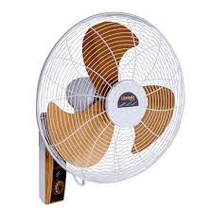

**Price: 11,300.00**

Elegant bracket fans refer to stylish, wall-mounted or ceiling-mounted fans designed with an aesthetically pleasing appearance while offering efficient airflow. These fans typically feature sleek, modern designs and high-quality materials that enhance the decor of a room, while providing reliable performance and adjustable airflow for comfort. They combine functionality with sophistication, making them suitable for both residential and commercial spaces.

**Key features of royal elegant bracket fans include:**

* **Stylish Design:** Sleek, modern aesthetics to complement various interior decors.
* **Space-Saving:** Wall or ceiling-mounted to optimize room space.
* **Quiet Operation:** Runs smoothly with minimal noise for a comfortable environment.
* **Adjustable Airflow:** Multiple speed settings and directional control.
* **Durability:** Made from high-quality materials for long-lasting performance.
* **Energy Efficiency:** Designed to consume less power while providing effective cooling.